

**UNIVERSITY OF GHANA**

(All rights reserved)

**Course Code and Title:** CPEN 103 -Computer Engineering Innovations

**Course Instructor:** Isaac Adjaye Aboagye, PhD

Simple Light Sensor Circuit using LDR

Group 7

Members

Rapheal Kuayi-10970285

Prince Charles Oheneba Nkyi 10956252

Edward Acquah 10986982

Delchris Daniels 10980292

Evans Acheampong 10987644

Eyram

Boniface Delano Dakey 10969344

Abstract:

The light sensor circuit is one of the coolest circuits in basic **electronics projects**. It detects the quantity of light present in the environment and the results can be detected by the brightness of the LED. This circuit may be useful for knowing the working of LDR (Light Dependent Resistor) or Photoresistor, the working of NPN Transistor, and the impact of the sensitivity of the resistor on the circuit. These types of circuits are useful when we need to know the presence and absence of lights on the premises.

Uses of Light sensor circuits are in the industry as well as Commercial and non-commercial areas. We can save power in and outside the premises by using this circuit. Street lights are glowing in the daytime by negligence so we can control these lights accordingly. Lights sensors can also detect light that is not visible by the human eye like x-rays.

1. INTRODUCTION

The controlling of the street lights making a light sensor circuit outdoor lights, a few indoor home appliances, and so on are usually maintained and operated manually on several occasions. This is not only risky but also results in wastage of power with the negligence of personnel or unusual circumstances in controlling these electrical appliances on and off. Hence, (based on the requirement) we can utilize the light sensor circuit for automatic switching of the loads based on daylight’s intensity by using a light sensor. In this article, we discuss in brief how to make a light sensor circuit and its working operation.

Before going to learn about the light sensor, primarily, we must know what a sensor. A sensor is a device that is used to detect changes in quantities or events and appropriately produce the outputs.

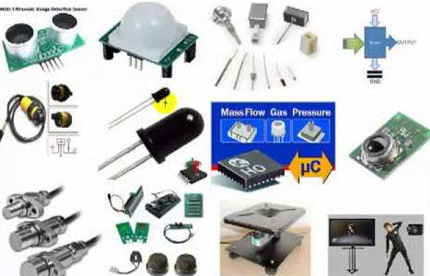

Different Types of Sensors

There are different [types of sensors](https://www.watelectronics.com/different-types-of-sensors-with-applications/) such as light sensors, [sensors](https://www.watelectrical.com/6-different-types-of-temperature-sensors-with-their-specifications/), [sensors](https://www.watelectronics.com/humidity-sensor/), pressure sensors, fire sensors, ultrasonic sensors, [sensors](https://www.watelectronics.com/ir-sensor/), touch sensors, and so on.

The light sensor circuit is a simple electrical circuit, which can be used to control the (switch on and off) electrical load appliances like lights, fans, coolers, air conditioners, street lights, etc., automatically. By using this light sensor circuit, we can eliminate manual switching as the loads can be controlled automatically based on the daylight intensity. Hence, we can describe it as an automatic light sensor.

The light sensor circuit helps to evade the manual control of the street lights erected on highways which is risky and also causes wastage of power. The light sensor circuit consists of [major electrical and electronic components](https://www.watelectrical.com/electrical-substation-components/) such as a light sensor, Darlington pair, and relay. To understand the working operation of the light sensor circuit, we must know a brief about the components used in designing the light sensor circuit.

1. SYSTEM DESIGN AND METHODOLOGY

Components and their uses

1. Printed circuit boards (PCBs): are used to mechanically support and electrically connect electronic components using conductive pathways, tracks or signal traces.

2. Connecting wires: Wires are used for establishing electrical conductivity between two devices of an electrical circuit. They possess negligible resistance to the passage of current.

3. Resistors (4.7k,10k ohms): implements electrical resistance as a circuit element.

4. NPN transistor: used for current amplification.

5. Light Emitting Diode (LED): It allows you to know if the current is passing through the circuit hence serves as the light source.

6. Light-dependent resistor: used for the detection of high levels of light in the electronic circuit.

7. 5V battery: serves as the source of power to the electronic circuit.

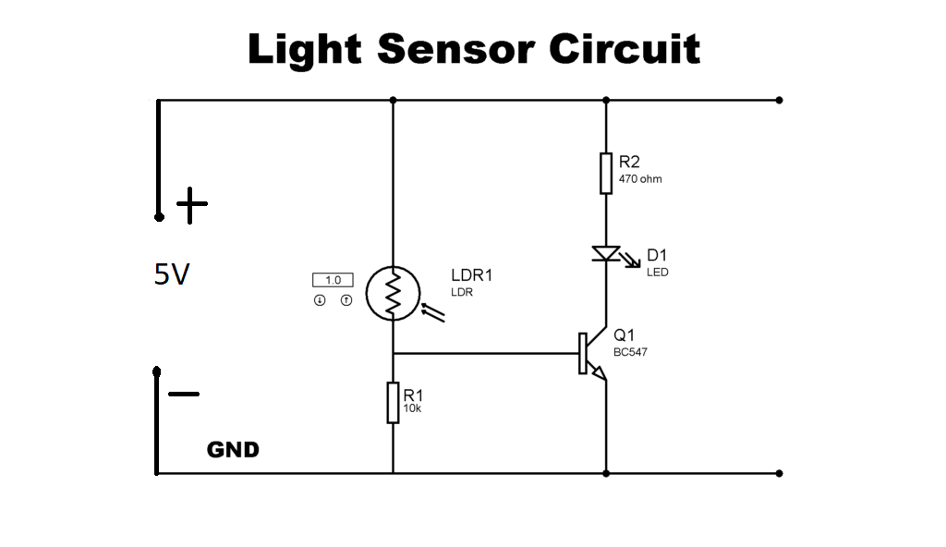

Procedure:

Firstly, connect LDR on Breadboard then connect the base of the transistor to one pin of Light-dependent resistor (LDR). On the other end connect an LED to two parallel pins of Breadboard. Now a resistor of 470 Ohms needs to be connected to the positive terminal of LED to the positive rail of the PCB board and the second resistor of 10K ohm needs to be connected to the base of the transistor to the negative rail of the breadboard. Now connect jumpers between the negative terminal of the LED to the collector pin of the transistor and from the emitter of the transistor to the negative rail of the PCB board and from the remaining LDR pin to the positive rail of the PCB Board. Finally, connect a battery to the Breadboard and test the circuit.

Conclusion

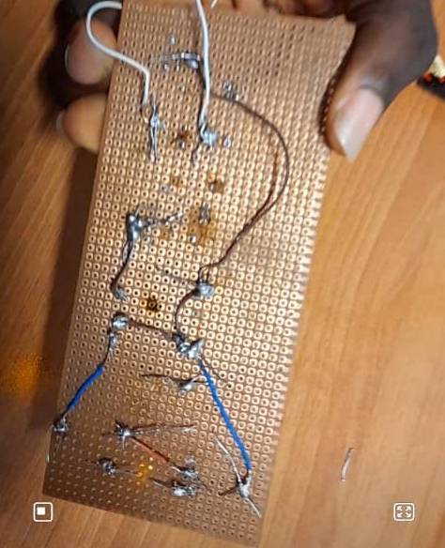

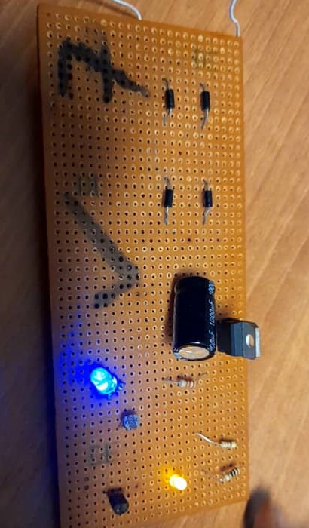

At the end of the project; When the brightness of light increases in the light sensitive circuit,, the LDR's resistance reduces and so the voltage at the base of transistor increases (because if LDR resistance reduces, the voltage drop(gap) across the LDR, towards positive side decreases). Once this voltage increases above the required threshold voltage at the base, the LED turns on. You can now visualize what happens when you reduce the brightness of ambient light.

References

[1] Elonics.in (2020, Jun. 30). Conclusion of the Simple Light Sensor Circuit using LDR

[Online]Available: http://elonics.in/breadboard-projects/light-sensor-and-darkness-detector-circuit-using-ldr-transistor

[2] [WatElectronics.com](https://www.watelectronics.com/) (January 7, 2021). What a light sensor circuit is and its operations

[Online]Available: <https://www.watelectronics.com/light-sensor-circuit-working-operation/>

[3] Circuits-diy.com (August 26, 2019) Abstract and the procedure involved in the making of light sensor circuits.

[Online]Available: https://circuits-diy.com/simple-light-sensor-circuit-using-ldr/

[4] DesignSpark (29th Apr 2021). Uses of the various components including the NPN Transistor

[Online]Available: https://www.rs-online.com/designspark/what-is-npn-transistor-definition-types-applications